**Cell Description:**This is a standard 3 input AND OR INVERT (AOI) cell. This cells functionality is described by the following Boolean equation:

$$Y= ¬((A⋀B)⋁C)$$

**Truth Table:**

|  |  |  |  |
| --- | --- | --- | --- |
| **A** | **B** | **C** | **Y** |
| 0 | 0 | 0 | 1 |
| 0 | 0 | 1 | 0 |
| 0 | 1 | 0 | 1 |
| 0 | 1 | 1 | 0 |
| 1 | 0 | 0 | 1 |
| 1 | 0 | 1 | 0 |
| 1 | 1 | 0 | 0 |
| 1 | 1 | 1 | 0 |

**Behavioral Verilog:**//Verilog HDL for "Lib6710_06", "AOI21X1" "behavioral"

module AOI21X1( Y, A, B, C );

input A;

input C;

output Y;

input B;

assign Y = ~((A&B) | C);

specify

(A => Y) = (1.0, 1.0);

(B => Y) = (1.0, 1.0);

(C => Y) = (1.0, 1.0);

endspecify

endmodule

**Cell Size:**

|  |  |  |
| --- | --- | --- |
| **Drive Strength** | **Height (μM)** | **Width (μM)** |
| AOI21X1 | 27.0 | 9.6 |

**Performance:**

**Propagation Delay (Rising Outputs):**

|  |  |  |
| --- | --- | --- |
| **Drive Strength** | **Min. (nS)** | **Max. (nS)** |
| AOI21X1 | 0.249604 | 3.820011 |

**Propagation Delay (Falling Outputs):**

|  |  |  |
| --- | --- | --- |
| **Drive Strength** | **Min. (nS)** | **Max. (nS)** |
| AOI21X1 | 0.367765 | 5.978167 |

**Output Fall Time:**

|  |  |  |
| --- | --- | --- |
| **Drive Strength** | **Min. (nS)** | **Max. (nS)** |
| AOI21X1 | 0.287229 | 4.7676 |

**Output Rise Time:**

|  |  |  |
| --- | --- | --- |
| **Drive Strength** | **Min. (nS)** | **Max. (nS)** |
| AOI21X1 | 0.207889 | 3.20355 |

**Logic Symbol:**

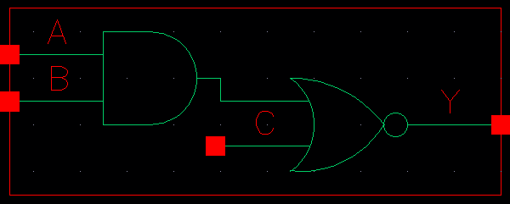

Figure : Symbol View for the AOI21 cell.

**CMOS Schematic:**The following figure displays the CMOS schematics for the AOI21 cell

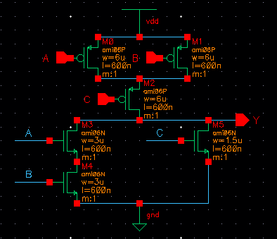

Figure : CMOS Schematic for the AOI21X1 cell.

**CMOS Layout:**

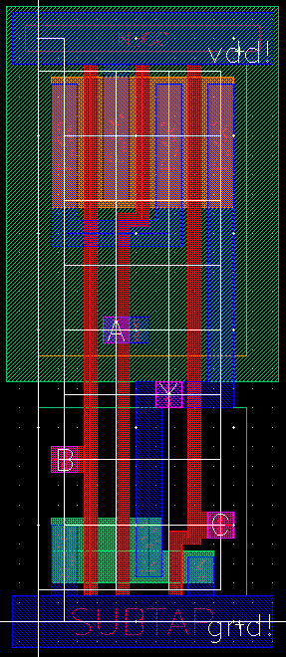

Figure : CMOS layout for the AOI21X1 cell.